PHY1010 Readings & Assignments: Week 5

Week 5 Reading
Complete the following reading early in the week:
- Week 5 online lectures
From the assigned textbook Physics, read:
- Fluids
  - Density
  - Archimedes' Principle and Buoyancy
- Temperature and Heat
  - Temperature and the Zeroth Law of Thermodynamics
  - Heat and Mechanical Work
  - Specific Heat
- Waves and Sound
  - Types of Waves
  - Waves on a String
  - Harmonic Wave Functions
  - Sound Waves
- Geometrical Optics
  - Reflection of Light
  - Forming images with a Plane Mirror
  - Spherical Mirrors
  - Ray Tracing and the Mirror Equation
  - The Refraction of Light
  - Ray Tracing for Lenses
- Following topics from the web site http://www.glenbrook.k12.il.us/gbssci/phys/Class/sound/soundtoc.html
  - The nature of a sound wave
  - Sound properties and their perception
  - Behavior of sound waves
  - Musical instruments
Week 5 Assignments Overview
Assignment Summary | Due Date
Assignment 1: Discussion Questions | Friday, December 11, 2009
Assignment 2: Quiz | Monday, December 14, 2009
Assignment 3: Reflection of Light Exercise | Sunday, December 13, 2009
Assignment 4: Refraction Experiment | Sunday, December 13, 2009
Remember that all Assignment details can be found on the assignment pages located throughout the week. Go to those specific pages for direction on how to complete each individual assignment.

Week 5 Overview
Apply the basic principles of physics to everyday phenomena:
- Buoyancy and floatation.
- Stresses and strains in materials.
- Properties of sound waves.
- Temperature.
- Heat capacity and specific heat.
- Specific heat of water.
- Conversion of water into steam and ice.
- Images formed by mirrors and lenses.
- Images formed by the eye.

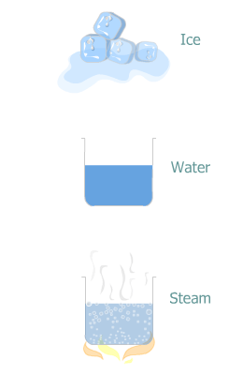
States of Matter
Everything that we see around is matter. From mountains to fountains, and balloons to the air filled in them all things constitute matter.
All matter is composed of tiny particles called atoms. These are so minute that they can't be seen individually by human eye, but they combine together to form bigger particles called molecules, which in turn combine in various patterns to form the wide variety of objects around us.
Matter exists in three states: solid, liquid, and gas. Solids are hard so they have a definite shape. Liquids and gases can flow and take the shape of the container in which they are kept. It's the arrangement and spacing of atoms and molecules in a substance that determines whether it's a solid, liquid, or gas.
In a solid the atoms or molecules are arranged in regular patterns, exert forces on each other, and are quite rigid. In a liquid the atoms and molecules exert much less force on each other and consequently have no definite shape of their own. In a gas the atoms or molecules are almost independent of each other, and the forces between them are very weak. They occupy the entire volume of their containing vessel.
Liquids and gases together are known as fluids. Fluids have the property of exerting a force on the objects immersed in them. This week we start our study with this property of fluids. Then we'll study about heat, sound and light.

Buoyancy
Some objects such as a log of wood float in water whereas some other objects such as a pebble sink. Clearly it's not the weight of the object that determines whether it will float or not; otherwise, the log should not float and the pebble should not sink. Floating or sinking of an object in a fluid depends on the force exerted by the fluid on the object.

The Archimedes principle
The principle that governs buoyant force or buoyancy is called the Archimedes principle; named after its discoverer Archimedes. According to this principle when an object is immersed in a fluid, it experiences an upward force, called buoyant force, equal to the weight of the fluid that the object displaces.
The buoyant force experienced by an object immersed in a fluid depends on the density of the fluid. Density of a material is its mass divided by its volume. The SI unit of density is kg/m³.
Density = Mass / Volume.
The floating and sinking of an object depends on the density of the object as compared to the density of the fluid. An object whose density is more than the density of the fluid sinks, and an object whose density is less than the density of the fluid floats. Due to buoyant force an object weighs lighter in a fluid. So if you weigh a steel ball inside water, it weighs less than when you weigh it in air. For the same reason a swimmer feels lighter in water.
The buoyant force acting on a body immersed in a fluid can be calculated as shown in the example that follows.
Example 5.1:
Calculate the buoyant force on a steel ball (density = 7900 kg/m³) immersed in water (density = 1000 kg/m³). The volume of the steel ball is 1 m³. (Assume g = 10 m/s²)
Solution:
According to Archimedes principle buoyant force is equal to the weight of the water displaced by the steel ball. Our task is now to calculate the weight of the water displaced by the steel ball.
Recall that weight = mass * g………………………………………..Equation (1)
And density = mass / volume………………………………………..Equation (2)
Since the steel ball is completely immersed in water, the volume of water displaced will be equal to the volume of the steel ball which is 1 m³.
Density of water = 1000 kg/m³
Substituting the values of density and volume in equation (2)
1000 kg/m³ = mass / 1m³
Or mass = 1000 kg/m³ x 1m³
= 1000 kg
g = 10 m/s²
The weight of the water displaced is obtained from equation (1)
Weight = 1000 kg x 10 m/s²
= 10,000 kg m/s²
= 10,000 N
Weight of the water displaced = 10,000 N
The buoyant force on the steel ball is 10,000 N.

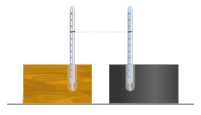
Heat
When different objects are heated, their temperatures don't increase by the same amount. Why is this so? What are heat and temperature? How are they related? Let's find out the answers to these questions.

What is Heat?
Heat is a form of energy and can be transferred from one object to another. When two objects are brought into contact, heat energy flows from hotter to colder object. After some time when enough heat energy is transferred, the transfer of heat stops and the objects are said to be in thermal equilibrium.

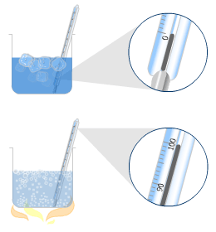
What is Temperature?
Temperature is the degree of "hotness" or "coldness" of a body. So when objects are in thermal equilibrium with one another, they have the same temperature.
The SI unit of temperature is kelvin (K). Other commonly used unit of temperature is Celsius. A degree on the Kelvin scale corresponds to a degree on the Celsius scale, but the zero of the Kelvin scale is not the same as the zero of the Celsius scale. So while the freezing point of water on the Celsius scale is 0 º C, it is 273 K on the Kelvin scale.
The temperature at which water converts to steam at atmospheric pressure is assigned 100 º C. Can you guess what is this temperature on the Kelvin scale? It is 100 + 273 = 373 K.

Unit of Heat
Before it was discovered that heat is a form of energy, a unit of heat called calorie was used to measure heat. One calorie of heat is defined as the amount of heat required to raise the temperature of 1 gram of water by 1 º C.
In 1847 James Joule showed that heat is a form of energy and through experiments found the relation between calorie and joule, which you already know is the unit of energy. He found that:
1 calorie of heat = 4.19 J

Specific Heat
Let's come back to the question stated at the beginning of this lecture. When you heat an object, its temperature increases but the rise in temperature is not the same for all objects. Why is this so?
The rise in temperature of a substance depends on the material and quantity of the substance. Experiments have shown that a fixed amount of heat energy is required to change the temperature of one kg of a material by 1 º C. This amount of heat is called specific heat of the material and it is unique for a material.
The SI unit of specific heat is J/kg K. Another commonly used unit of specific heat is cal/kg º C.
The specific heat of water is 1000 cal/kg º C. This means that we require 1000 cal of heat energy to increase the temperature of 1kg of water by 1 º C.

If specific heat of a material is known, we can calculate exactly how much heat will be required to change the temperature of a unit mass of the material. The following relation helps to calculate this.
Q = m c ΔT
Here
Q is the heat absorbed or given out
m is the mass of the object
c is the specific heat of the material
ΔT is the change in temperature of the object
Let's solve a problem based on the equation Q = m c ΔT.
Example 5.2:
Find out how much heat is required to raise the temperature of one kg of water from 25 º C to 100 º C. Express the answer in joules. (Specific heat of water = 1000 cal/kg º C)
Solution:
Here m = 1 kg,
c = 1000 cal/kg º C,
And ΔT = 100 º C - 25 º C
= 75 º C.
Q = m c ΔT
Q = 1(kg) x 1000 (cal/kg º C) x 75 (º C)
= 75,000 cal
Since 1 cal = 4.19 J
75,000 (cal) = 75,000 (cal) x 4.19 (J/cal)
= 314000 J
The amount of heat energy required to raise the temperature of one kg of water from 25 º C to 100 º C is 314000 J.

Heat not only raises the temperature of a substance, it can also changes its state. It's a common phenomenon that ice melts on heating i.e. it changes from solid to liquid state. Similarly heating water (liquid) converts it into steam (gas).
Experiments have shown that when a material changes its state some amount of heat is absorbed or given out by it. During this process the temperature of the substance does not change.

Heat of Fusion
The amount of heat required to change the state of a unit mass of a substance from solid to liquid state at constant temperature is called the heat of fusion, and it is denoted by L_{f}. For ice the heat of fusion is about 80 cal/g. This means that 80 cal of heat is required to melt 1 g of ice to water at 0 º C.

Heat of Vaporization
The amount heat required to convert a unit mass of a substance to its vapor at constant temperature is called the heat of vaporization, and it is denoted by Lv. The heat of vaporization of water is 539 cal/g. This means 539 cal of heat is required to vaporize 1 g of water to steam at 100 º C.
Let's solve a problem based on the heat of fusion.
Example 5.3:
How much heat is required to completely melt 200 g of ice at 0 º C? Express the answer in joules.
(L_{f} of ice = 80 cal/g)
Solution:
L_{f} of ice = 80 cal/g
This means to convert 1 g of ice to water heat required = 80 cal.
Therefore to convert 200 g of ice to water heat required = 200 x 80 cal.
= 16000 cal
1 cal = 4.19 J
Therefore 16000 (cal) = 16000 (cal) x 4.19 (J/cal)
= 67000 J

Sound Waves
Sound is an important means of communication. When you have to convey your ideas to someone, you just talk to them. Can you imagine a world without sound? It would be pretty difficult to live in a world without sound. What is sound, and how does it travel? Sound is a mechanical wave or disturbance that travels through a medium. So when you talk to someone, the air is disturbed in a certain pattern. This disturbance travels to the ears of the other person. Note that a sound wave does not transport material particles from one point to another it only transmits energy or information.

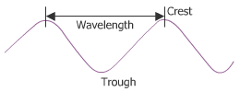
Characteristics of a Wave
There are certain characteristics of a wave that are applicable to sound waves also. Let's learn about them. Look at the graphic shown here. It describes a typical wave. The highest part of a wave is known as a crest, and the depression between two crests is known as a trough.
Any wave can be described by two characteristics - its wavelength and its frequency.
The wavelength 'λ' of a wave is the distance between successive crests or troughs of the wave.
The frequency 'f' of a wave is the number of crests or troughs that pass through a particular point in one second. The unit of frequency is second⁻¹ and is called hertz (Hz). The product of the wavelength and frequency of a wave is the speed with which the wave travels. Human ear can hear sounds with frequencies ranging from 20 Hz to 20,000 Hz.
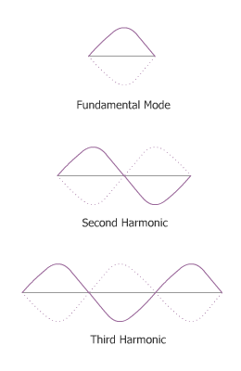
The speed with which sound waves travel through a medium depends on the properties of the medium and is the same for all frequencies. Sound waves travel through air at 20.0 C with a speed of 343 m/s.

Sound and Music
Let's try to understand musical sounds in terms of the characteristics of sound waves. Let's see how a vibrating string produces musical sounds.

Vibrating Strings
A guitar string when plucked produces sound at a frequency at which the string vibrates. The frequency of vibration of a string means the number of times the string vibrates back and forth in one second. For example a guitar string vibrating 880 times a second will produce a sound wave of 880 Hz.
A string fixed at its ends vibrates only at certain fixed frequencies. When it vibrates at its lowest frequency it is called the fundamental mode and it produces its fundamental frequency or first harmonic frequency. The string can also vibrate with frequencies that are integral multiples of the fundamental frequency. The example that follows will clarify this idea better.

Example:
A guitar string is vibrating at its first harmonic frequency at 440 Hz. What are the other frequencies that this string can produce?
Solution:
The other frequencies at which the string will vibrate are multiples of the fundamental frequency of 440 Hz. The second harmonic frequency is 2 x 440 = 880 Hz.
The third harmonic frequency is 3 x 440 = 1320 Hz. Other harmonics in integral multiples of 440 Hz can also be present.

Light
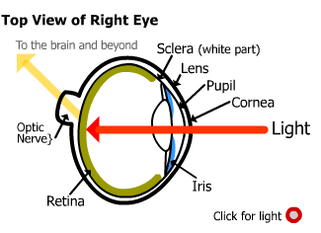
Almost all the information that we receive about our world is through light. Light like sound is a wave; but unlike sound, it does not require a medium to propagate. Light is a wave that travels even in vacuum and like any wave, light waves also have a wavelength and a frequency. In fact, light of different colors have different frequencies. Sunlight is a mixture of many colors. When sunlight is passed through a prism it breaks up into different colors. This phenomenon is also observed when a rainbow is formed in the sky. Little drops of water in the air act like tiny prisms and break up the sunlight into the beautiful colors of the rainbow.
You may recall that for a sound wave the product of its frequency and wavelength is equal to the speed with which the sound travels. Similarly, the wavelength of light when multiplied by its frequency gives the speed of light.
Sound waves travel through air at around 340 m/s whereas light travels at 3 x 10⁸ m/s. That is the reason why you see a lightning flash in the sky before you hear the thunder. The light travels faster than the sound and reaches you first.

How do we see Objects?
Light enables us to see objects around us. When light from an object reaches our eye, the lens of our eye forms an image of the object on a special organ, called retina, in our eye. The image is then converted into electrical signals that are interpreted by the brain as the sensation of sight.
We can see the things around us but to see ourselves we usually need a mirror. When you look at yourselves in a mirror, you are actually seeing your image that is formed by the mirror. Let's see how mirrors and lenses form images when light falls on them.

Plane Mirrors
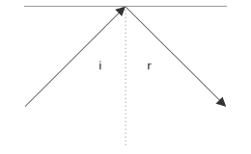
When light falls on a mirror, the mirror reflects the light. Ray diagrams help understand reflection of light. A ray is a thin pencil of light. When a light ray falls on a mirror at an angle, called the angle of incidence, it is reflected back by the mirror at an angle, called the angle of reflection.
The reflection of light takes place in conformity to the law of reflection, which states that the angle of incidence is equal to the angle of reflection. Both the angle of incidence and the angle of reflection are measured from the normal or perpendicular drawn to the surface at the point of incidence as shown in the graphic.
When a ray of light from a point object is reflected from a plane mirror and enters the eye, the brain interprets the ray as coming from behind the mirror rather than as a reflected ray. The eye sees a virtual image of the object A at the point A'.
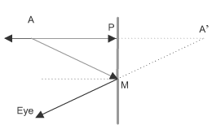
Drawing two rays and finding their point of intersection after reflection from the surface can find the position of the image of a point object. This is a general method that can be used for mirrors as well as lenses. Use the following guidelines to draw ray diagrams:
- Draw a ray perpendicular to the mirror. This ray will be reflected back along the same path.
- Draw another ray at an angle to the mirror. The reflected ray will make the same angle to the normal as the incident ray.
- The two reflected rays diverge from each other after reflection. So they cannot form a real image. But when the two reflected rays are extended behind the mirror, they meet at A'. This is a virtual image because if you place a screen at that point, no image can be formed. Light only appears to be emerging from that point.

Spherical Mirrors
A plane mirror forms images of the same size as the object. Spherical mirrors magnify or reduce the size of the image of an object. Spherical mirrors are used as shaving mirrors, makeup mirrors, and rear view mirrors in automobiles. A spherical mirror is a small part of a spherical surface. A spherical mirror can be concave or convex. A concave mirror has its reflecting surface on the inside of the sphere, while a convex mirror has its reflecting surface on the outside of the sphere.
A concave mirror is usually used for magnifying an object like in shaving mirrors or makeup mirrors. The mirror is placed close to the object and a magnified virtual image is formed behind the mirror.
In a convex mirror, because of its wide angle of vision, is used as side view mirrors in automobiles and as surveillance mirrors in buses and stores.

Lenses
To understand how lenses form images we need to learn about refraction of light.

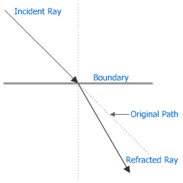
Refraction of light
When light travels from one medium to another, it changes direction. This happens because light travels with different speeds in different mediums. This phenomenon is called refraction of light. The extent of refraction depends upon the refractive indices of the mediums at whose boundaries refraction occurs.
The refractive index of a medium is defined as the ratio of the speed of light in vacuum to the speed in that medium. Water has a refractive index of 1.33 whereas crown glass has a refractive index of 1.52.

Lenses
Most optical equipment such as microscopes, telescopes, and cameras use lenses for magnifying or focusing images. A lens consists of two curved surfaces that have a common axis. Like spherical mirrors lenses also are of two basic types. There are convex and concave lenses.

Convex Lens
A convex lens has two surfaces arranged so that it bulges in the middle and is thinner at the edges. A convex lens is also called a converging lens because light rays parallel to the principal axis of the lens converge at a point called the focus. This is due to the double refraction of the rays at the two surfaces of the lens.
Image formation in a lens can be found by the method of ray tracing. When an object is located between focus F1 and the lens a magnified image of the object is formed by the convex lens.

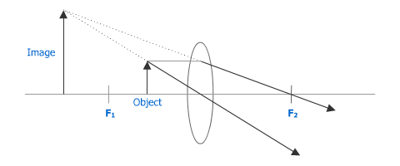

Concave Lens
In a concave lens the middle part of the lens is the thinnest, while the outer edges are the thickest. A concave lens is also called a diverging lens because rays parallel to the axis are refracted and appear to diverge from a focal point.

Weekly Summary
We have reached the end of Week 5. This week covered buoyancy, heat, sound waves, and light. These concepts enable you to understand physical phenomena observed in daily life. The assignments will also help you relate and apply the concepts better.

Assignment 1: Discussion Questions
By Friday, December 11, 2009 respond to the discussion questions assigned to you by the facilitator. Submit your responses to the appropriate Discussion Area. Start reviewing and responding to your classmates as early in the week as possible. You can ask technical questions or respond generally to the overall experience. Be sure to be honest, clear, and concise. Always use constructive language, even in criticism, to work toward the goal of positive progress.
Grading Criteria | Maximum Points
Correct spelling and grammar. | 4
Well-formed conclusions. | 12
Participation and feedback in discussion. | 8
Total: | 24
For assistance with any problems you may have when completing this assignment—OR—to offer your assistance to classmates, please use the Problems and Solutions Discussion area located through the left side navigation link.
Q1 - How can you demonstrate that water is denser than ice without weighing them? What is the principle involved?
Q2 - The density of water is a maximum at 4°C. Why is this property of water important for aquatic life?
1-How can you demonstrate that water is denser than ice without weighing
them ? What is the principle involved ?
Release an ice cube in water the ice cube will float . The ice cube will
displace some water as it ``pushes ' the water away . The principle
involved is displacement .
2-The density of water is a maximum at 4 ?C . Why is this property of
water important for aquatic life ?
The maximum density being attained at 4 ?C means that even if the water
gets colder , the density will decrease . Therefore , ice (when it forms )
floats instead of sinks . This makes the continuity of aquatic life
during winter possible .

Week 5 Quiz
1. A cubical object of sides 10 cm is immersed completely in water. What is the force of buoyancy on the object? (Assume g = 10 m/s²)

2. What is the frequency of a sound wave that has a wavelength of 1 m?
3. A vibrating guitar string vibrates in its fundamental mode at a frequency of 600 Hz. What is the third harmonic frequency of the string?
4. How much heat must a refrigerator remove from 100 g of water at 25⁰ C to convert it to ice at 0 ⁰C?

Assignment 3: Reflection of Light Exercise
By Sunday, December 13, 2009 please complete the following exercise and post it to the appropriate Discussion Area.
If you want to see yourself fully in a plane mirror, the mirror needs to be only half your height. Draw a ray diagram showing how this is possible. Explain the diagram and principles you used.
Grading Criteria | Maximum Points
Ray diagram. | 4
Explanation of the ray diagram. | 4
Explanation of the principle used. | 4
Total: | 12
For assistance with any problems you may have when completing this assignment—OR—to offer your assistance to classmates, please use the Problems and Solutions Discussion area located through the left side navigation link.

